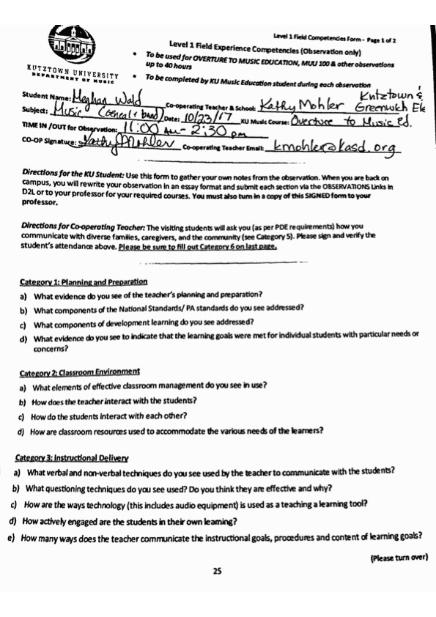

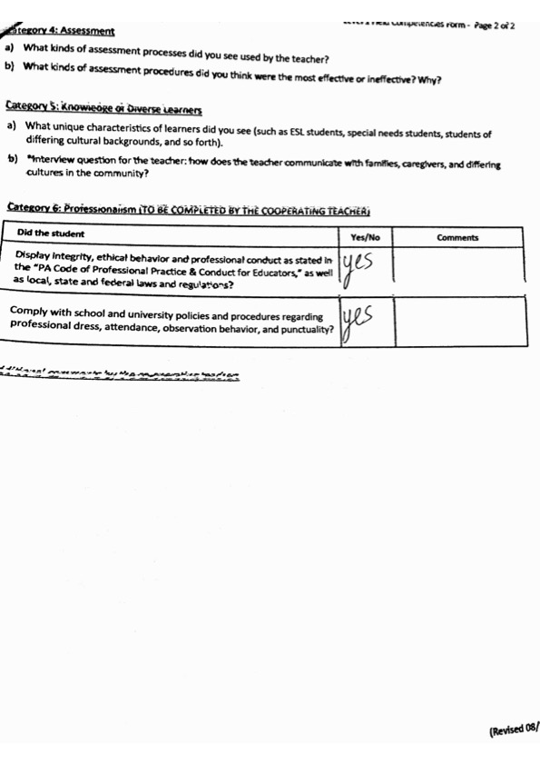

10/23/17

Category 1- Planning and Prep:

1. What evidence do you see of the teacher’s planning and preparation?   
   -Use of the same basic book within the lesson groups- Essential Elements  
   -clear, structured lessons. The students know exactly what to expect when they come in for lessons, they get more done  
   -all desks are prepared with folders and crayons for students before they even enter the classroom
2. What components of the National Standards/PA standards do you see addressed?   
   -in both choir and band all the students had opportunities to perform varied repertoire as an ensemble and alone  
   -both had opportunities for improvisation  
   -Choir was able to analyze and describe music. They also evaluated music and music performances.  
   -both groups had music history involved in Lessons. Choir learning currently about Beethoven, and trumpets discussed Mozart.
3. What components of development learning do you see addressed?   
   -The students understand what may affect their playing, there is development in their knowledge of the instruments and music they are playing to understand where they’re running into problems.
4. What evidence do you see to indicate that the learning goals were met for individual students with particular needs or concerns?   
   -Students usually cross off several excerpts from books during each lesson because they completed and understood the information in each section. This was determined by assessing how well they have improved. Others came in for extra lesson time because they were concerned with band music.

Category 2- Classroom Environment:

1. What elements of effective classroom management do you see in use?   
   -Use of the same beginner level book   
   -small lesson groups  
   -short but effective lessons. NO TIME WASTED   
   -lots of helpful posters around the classroom. LOTS OF RESOURCES FOR STUDENTS.   
   -reeds provided for students
2. How does the teacher interact with the students?   
   -Uses terms that elementary school students would understand.   
   -because they are young students, lots of praise for good playing/demonstration of skills.   
   -plays along with students in lessons   
   -speaks somewhat casually to keep them interested and able to comprehend the information presented in a given lesson time.   
   -Rewards system? (fake) Money?
3. How do the students interact with each other?   
   -in lessons, they usually start playing together but then the teacher goes back and forth teaching them individually.   
   -some students listen and participate by singing along when other students are playing.
4. How are classroom resources used to accommodate the various needs of the learners?   
   -everything that could be needed in a lesson is available. Students who have demonstrated higher understanding of skills have progressed further in their books or are playing certain excerpts at a faster tempi then other students.   
   -there is time for them to come in for extra help. There is also ample opportunity to get extra/more in-depth work.

Category 3- Instructional Delivery:

1. What verbal and non-verbal techniques do you see used by the teacher to communicate with the students?   
   -non-verbal instruction by playing with them.  
   -simple description, but precise instruction.   
   -sings other parts of the music when rehearsing with individual students on band pieces.   
   - “you have to know what is going to happen before it happens musically. Don’t react to missing”   
   -Counting rests out loud   
   -explain subtle differences between exercises.   
   -Review the refrain in song the choir is studying- 5th Grade “Lean on Me” (precious)  
   - tight run classroom due to time constraint. Warm up with a “fun” song to gather students’ attention. “Skin and Bone” for Halloween.  
   -every student has to stay attentive to not fall behind  
   -Students are taught to improvise rather casually- THEY ARE ALL EXCITED TO IMPROVISE TOGETHER  
   -New music in essentially every class to practice new skills- interwoven themes identified in new music- new sounds: minor= sad- dynamics: written out visibly with pictures and representations of themes that are pictured going higher and lower. “Dance Macabre”  
   -Instructional decision: explaining that if they had students from other countries (France- as the excerpt being played was a French Folk Song) they wouldn’t be able to say hello to each other, but they could all play this piece because music is a universal language.   
   -“blow from your belly”  
   - your tone is going to wobble if you are wobbling
2. What questioning techniques do you see used? Do you think they are effective and why?   
   -Questions asked of the students that make them think about their playing and they can use context clues and technique they already developed to answer. Ex: how can we learn to play louder? Where is the “volume button” on your trumpet?  
   -lead/prompt students to the correct answer.  
   -questioning through assessing playing.   
   - playing a game at the end of class as a reward for good behavior and getting through new material well.   
   - ask students what they feel is happening in their playing. “why is it sounding this way?” to get to the root of the problem.
3. How are the ways technology (this includes audio equipment) is used as a teaching and learning tool?   
   -metronomes, electric keyboard   
   -general music/choir- uses a recording to help guide soloists in how their solo sounds.   
    -also used as accompaniment for certain tunes  
   -electronic video and audio used to show students how to identify different themes and dynamics within music. A visual representation of a song is projected on the board as it is played, and the students follow along with the same visual concept written out in from of them.
4. How actively engaged are the students in their own learning?   
   -The students must practice in order to meet each goal for their next lesson.   
   - while one student is being worked with the other is working through an excerpt with the teacher.   
   - they are never doing the same things as any other students. They must be thinking and playing for themselves.
5. How many ways does the teacher communicate the instructional goals, procedures, and content of learning goals?   
   -clearly marking goals for the next lesson within the books of each student so that they know what to practice.   
   -“Gotta find 2 minutes”

Category 4- Assessment:

1. What kinds of assessment processes did you see used by the teacher?   
   - Assessing how well the students sight read and identify notes. While one student is playing and being assessed through playing the other is writing notes in the next excerpt of music   
   -choir/general music- quarterly vocal assessment. For vocal leadership within the ensemble- Grand old flag. Large part of their grade for the quarter.
2. What kinds of assessment procedures did you think were the most effective or ineffective? Why?   
   -effective Use of lesson books to see the progress of each individual student.  
    -could be ineffective because it does not keep entire band to one standard. However, it keeps kids who are more fluent in their instrument interested.

Category 5- Knowledge of diverse learners:

1. What unique characteristics of learners did you see (such as ESL, special needs, students of differing cultural backgrounds)   
   -because the students have very individualized and focused lessons, these special students are easily accommodated.   
   -students of all different playing abilities- some only started playing over the summer. Some started at the beginning of fourth grade. Some are just starting now.
2. Interview question: how does the teacher communicate with families, caregivers, and differing cultures in the community?   
   -Remind app- sent out every morning who has lessons and who needs instruments.   
   -once a week- weekly email (not every week)- schedule for this week and important dates for the fall.