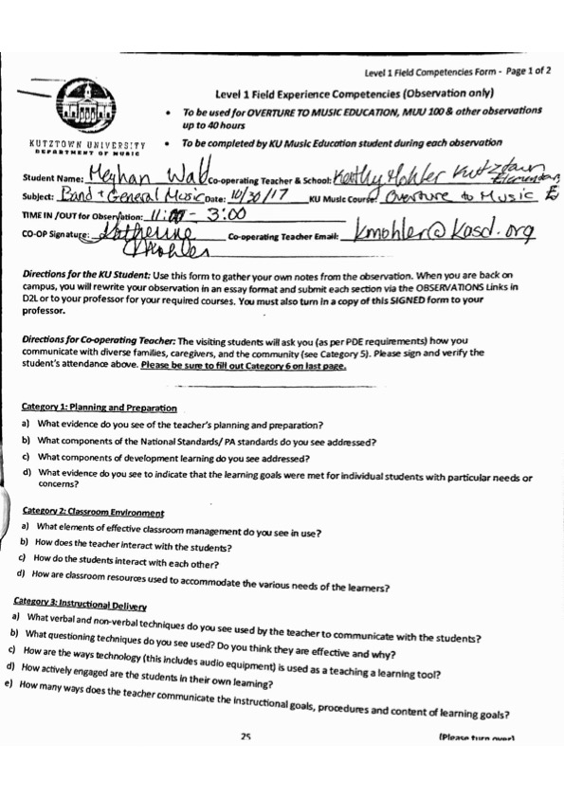

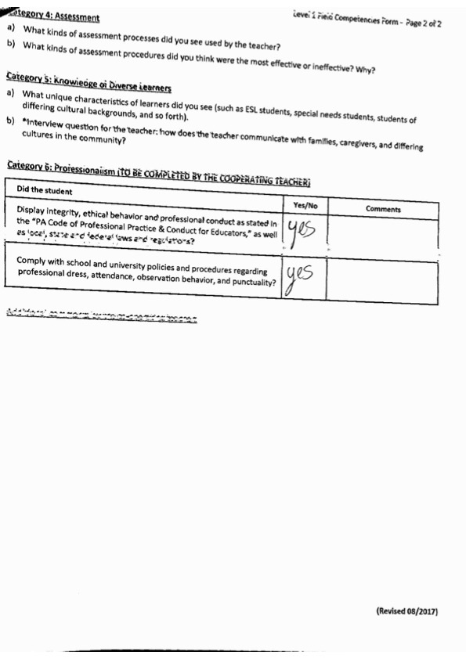

Category 1- Planning and Prep:

1. What evidence do you see of the teacher’s planning and preparation?   
   -all possible instruments out and available to use as demonstration  
   -use of the same essential elements book so one simple lesson plan can be used across the board
2. What components of the National Standards/PA standards do you see addressed?   
   -working on the student learning objectives.
3. What components of development learning do you see addressed?   
   -students are asked to assess themselves.   
   -students identify analyze and read music on their own. “what is going to be hard about this measure?” can be answered by students.
4. What evidence do you see to indicate that the learning goals were met for individual students with particular needs or concerns?   
   -they complete all the playing from their lesson books  
   -they are happy with the outcome of lesson- they still get a marble and sticker.

Category 2- Classroom Environment:

1. What elements of effective classroom management do you see in use?   
   -same lesson book  
   -same lesson schedule from week to week. Consistency  
   -kids have a lack of focus in this classroom.
2. How does the teacher interact with the students?   
   -plays with them, doesn’t teach at them.   
   -asks students to analyze music. “does this song have any repetitive parts?” Forces students to analyze music in a simple way.   
   -plays and listen to music. Analyze what they hear- instrumentation.
3. How do the students interact with each other?   
   -play with each other  
   -constructive criticism, but usually the students only critique themselves, not other students.
4. How are classroom resources used to accommodate the various needs of the learners?   
   -labeled note names and fingers in music.

Category 3- Instructional Delivery:

1. What verbal and non-verbal techniques do you see used by the teacher to communicate with the students?   
   -uses a pencil to point along in music while still playing with students during lessons when students get lost in music.   
   -simple speech that young kids would understand.   
   -be using the correct terms.   
   -allowing students to be creative. Rewriting lyrics.   
   -listening to a story associated with a piece of music. Identify parts of story in music.   
   -reading of music history book-Beethoven lives upstairs.
2. What questioning techniques do you see used? DO you think they are effective and why?   
   -how close are these notes? What should change when we play this one vs this one?   
   -what is the rhythm? What are these notes? What do we do to play this kind of note?
3. How are the ways technology (this includes audio equipment) is used as a teaching and learning tool?   
   -playing of the music they are studying

How actively engaged are the students in their own learning?   
 -practice logs signed by parents   
 -analyzing their own playing/performances.   
 -testing their own reading and sight-reading abilities.   
 -questioning and answering how to play certain notes, including what it feels like (embouchure/aperture)

1. How many ways does the teacher communicate the instructional goals, procedures, and content of learning goals?

Category 4- Assessment:

1. What kinds of assessment processes did you see used by the teacher?   
   -can a student identify notes without writing down note names?   
   -say the rhythm out loud “tah’s and te te’s” then say letters.   
   -marble and sticker?   
    -prize for getting everything done each week. IF the jar is full at end of quarter they get cookies.
2. What kinds of assessment procedures did you think were the most effective or ineffective? Why?  
   -identify if the students practiced by playing with them (and knowing how they play generally)

Category 5- Knowledge of diverse learners:

1. What unique characteristics of learners did you see (such as ESL, special needs, students of differing cultural backgrounds)   
   -kids with clear ADHD need new topics in order to keep their attention.
2. Interview question: how does the teacher communicate with families, caregivers, and differing cultures in the community?   
   -remind   
   -weekly email   
   -assignment books- to parents. How todays lesson went. (some parents never sign off)   
   -report card and newsletter. People still won’t know.