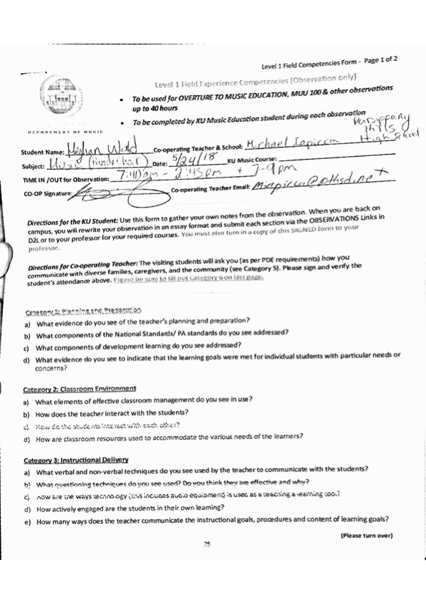

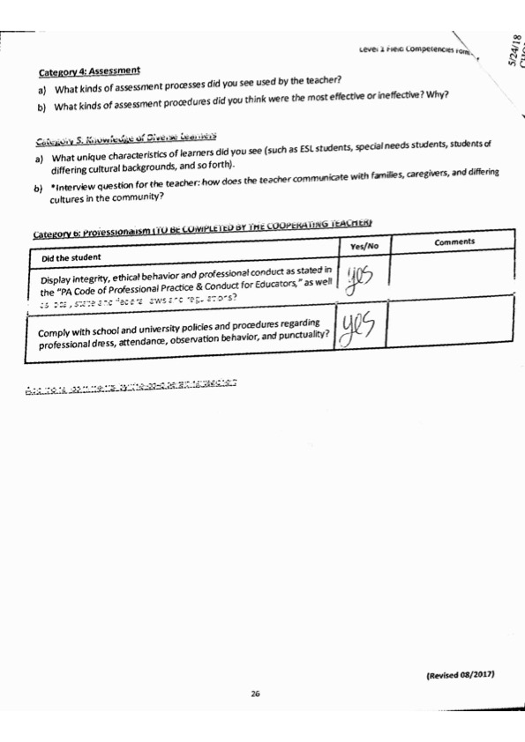5/24/18

GENERAL DAY   
Category 1- Planning and Prep:

1. What evidence do you see of the teacher’s planning and preparation?

Their concert is tonight, and therefore, she has done a lot of prep for tonight. Instead of having the students sing and possibly over use their voices she has them speak through their lyrics.

1. What components of the National Standards/PA standards do you see addressed?
2. What components of development learning do you see addressed?

High school students are essentially just learning how to apply other things they know from other classes into music and vice versa. For example, some songs are in languages other than English so that they can apply what they learn in their foreign language courses to music.

1. What evidence do you see to indicate that the learning goals were met for individual students with particular needs or concerns?

Category 2- Classroom Environment:

1. What elements of effective classroom management do you see in use?   
   teacher has control over the classroom even though it’s a very open classroom, allowing for communication between students and teacher.
2. How does the teacher interact with the students?   
   teacher is able to interact in a light hearted way and ask the students for their feedback and opinions on rehearsals, but also has control over the classroom.
3. How do the students interact with each other?   
   Students run stretches and warm ups, they also practice together before classes start. Students know warm ups well enough on their own to not need piano or teacher instruction to do warm ups.
4. How are classroom resources used to accommodate the various needs of the learners?   
   students are encouraged to do what they can; be comfortable with performances. If they need to sit down after standing on the risers for a long time they are encouraged to. Any students with physical disabilities are, obviously, positioned on the floor in front of the risers rather than on the risers.

Category 3- Instructional Delivery:

1. What verbal and non-verbal techniques do you see used by the teacher to communicate with the students?   
   Teacher conducts and clicks her fingers to keep students together when singing/speaking lyrics.
2. What questioning techniques do you see used? Do you think they are effective and why?   
   the instructor asks the students what they think needs improvement. This way the students learn to self asses.
3. How are the ways technology (this includes audio equipment) is used as a teaching and learning tool?   
   The PTHSD school district gives all their high school students ipads/chromebooks (they are transitioning to chrome books and therefore some older students still have ipads). So, all of their music is paperless.
4. How actively engaged are the students in their own learning?   
   students are very engaged. They are very concerned about the concert that they have tonight. They want their music to sound as good as possible, so they continued today to ask about reviewing certain songs and trouble spots.
5. How many ways does the teacher communicate the instructional goals, procedures, and content of learning goals?   
   The teacher writes on the board the order for the concert which she also intended to follow during their rehearsal today. However, some songs were skipped by request of the students to work on other music that they are concerned about tonight.

Category 4- Assessment:

1. What kinds of assessment processes did you see used by the teacher?   
   Although there wasn’t an actual test today (other than the concert) in class, the instructor was listening for mistakes and lyric inaccuracies.
2. What kinds of assessment procedures did you think were the most effective or ineffective? Why?   
   I think the form of having the students assess themselves and their own performances was very effective because it showed how they were listening and hearing themselves. They demonstrate a comprehension of musicianship when they are able to identify issues.

Category 5- Knowledge of diverse learners:

1. What unique characteristics of learners did you see (such as ESL, special needs, students of differing cultural backgrounds)   
   There were special needs students in the choir class that I observed. Many different cultural backgrounds were also present.
2. Interview question: how does the teacher communicate with families, caregivers, and differing cultures in the community?   
   Communicates through email with parents to set up phone calls or appointments when necessary. She prefers face to face contact so that the communication is not misinterpreted.

WIND ENSEMBLE

Category 1- Planning and Prep:

1. What evidence do you see of the teacher’s planning and preparation?

-Discussion of rehearsal/moving equipment many periods before large band rehearsal.

-Knows what exactly to work on with each student during their lessons

-Writing the agenda for the rehearsal on the board.

1. What components of the National Standards/PA standards do you see addressed?

-The students were required to understand the history of the music they played as well as a general knowledge of how to care for their instruments.

1. What components of development learning do you see addressed?

-All of these students have developed the skills that they use in wind ensemble over time. Tuning (both knowledge of their instruments and within a group), technical skill, breath support etc. have all been worked on for years. With their age they got better at

1. What evidence do you see to indicate that the learning goals were met for individual students with particular needs or concerns?

-Certain goals are set for certain groups, sections, and individuals. For the clarinets, it is to play with more resonance and less of a fuzzy sound

Category 2- Classroom Environment:

1. What elements of effective classroom management do you see in use?   
   -Organization, or at least working towards organization. (I don’t believe that any band room is every really organized.
2. How does the teacher interact with the students?   
   -The instructor knows exactly what to say to students when they have certain issues. Like when students who are playing the saxophone and moving their fingers off the pearls, he tells them in simple language, “keep your fingers on the pearls” and not t
3. How do the students interact with each other?   
   -Students non verbally communicate when playing. Using ears and eyes to make contact and fixing tuning and tempo mistakes.
4. How are classroom resources used to accommodate the various needs of the learners?   
   -Students are allowed the opportunity to use school instruments rather than having to rent or own their own instruments.

Category 3- Instructional Delivery:

1. What verbal and non-verbal techniques do you see used by the teacher to communicate with the students?   
   -Lots of singing and discussion of the articulation “sound” that should be used to play with certain styles. Non-verbal conducting and pointing, to indicate entrances and tuning issues.

-Instructor plays with students during lessons to help with tuning and with phrasing. Demonstration.

1. What questioning techniques do you see used? Do you think they are effective and why?   
   -Asks the students where they think they can improve. This really helps to have the students demonstrate comprehension of musicianship.
2. How are the ways technology (this includes audio equipment) is used as a teaching and learning tool?   
   -All of their music is on their ipads or chromebooks; everything is digital.
3. How actively engaged are the students in their own learning?   
   -Students are engaged in their own learning. They express concerns with musicality and musical errors.
4. How many ways does the teacher communicate the instructional goals, procedures, and content of learning goals?   
   -Listing the goals for the day on the board. Telling the students what they need to cover during certain songs in order to make fixes for the concert tonight.

Category 4- Assessment:

1. What kinds of assessment processes did you see used by the teacher?   
   -Takes the time out of the day to sit in the auditorium and listen to his ensembles play. Rather than standing in the conductors spot, he lets the band play on their own and then gives feedback based on how the full sound of the group sounds (or will sound) to the audience.
2. What kinds of assessment procedures did you think were the most effective or ineffective? Why?   
   -Having the students play without a conductor keeping time, just showing dynamics, was effective in testing the students focus and musicianship in keeping the tempo.

Category 5- Knowledge of diverse learners:

1. What unique characteristics of learners did you see (such as ESL, special needs, students of differing cultural backgrounds)   
   -There were special needs student in the band classes. Many students were also of different cultural backgrounds.
2. Interview question: how does the teacher communicate with families, caregivers, and differing cultures in the community?   
   -Communication is through email if parents need to be contacted. Normally high school students can manage themselves and check google classroom or the remind app for updates. If an email is sent to parents with a schedule its normally for the marching band or field trip information. Otherwise talking to parents and other administration and community outreach is at concerts or through performances. Community outreach through performance. Volunteer concerts, playing in parades.

CHOIR

Category 1- Planning and Prep:

1. What evidence do you see of the teacher’s planning and preparation?

Their concert is tonight, and therefore, she has done a lot of prep for tonight. Instead of having the students sing and possibly over use their voices she has them speak through their lyrics.

1. What components of the National Standards/PA standards do you see addressed?

Students have to understand how to take care of their own instruments (voices), as well as historical background of the music they are singing and they have to understand general musicianship.

1. What components of development learning do you see addressed?

High school students are essentially just learning how to apply other things they know from other classes into music and vice versa. For example, some songs are in languages other than English so that they can apply what they learn in their foreign language courses to music.

1. What evidence do you see to indicate that the learning goals were met for individual students with particular needs or concerns?

When students did have concerns they were addressed quickly and effectively. Using teaching techniques that were more visualization then they were directing physical adjustments, like asking students to think about being more open or projecting their sound behind their head.

Category 2- Classroom Environment:

1. What elements of effective classroom management do you see in use?   
   teacher has control over the classroom even though it’s a very open classroom, allowing for communication between students and teacher.
2. How does the teacher interact with the students?   
   teacher is able to interact in a light hearted way and ask the students for their feedback and opinions on rehearsals, but also has control over the classroom.
3. How do the students interact with each other?   
   Students run stretches and warm ups, they also practice together before classes start. Students know warm ups well enough on their own to not need piano or teacher instruction to do warm ups.
4. How are classroom resources used to accommodate the various needs of the learners?   
   students are encouraged to do what they can; be comfortable with performances. If they need to sit down after standing on the risers for a long time they are encouraged to. Any students with physical disabilities are, obviously, positioned on the floor in front of the risers rather than on the risers.

Category 3- Instructional Delivery:

1. What verbal and non-verbal techniques do you see used by the teacher to communicate with the students?   
   Teacher conducts and clicks her fingers to keep students together when singing/speaking lyrics.
2. What questioning techniques do you see used? Do you think they are effective and why?   
   the instructor asks the students what they think needs improvement. This way the students learn to self asses.
3. How are the ways technology (this includes audio equipment) is used as a teaching and learning tool?   
   The PTHSD school district gives all their high school students ipads/chromebooks (they are transitioning to chrome books and therefore some older students still have ipads). So, all of their music is paperless.
4. How actively engaged are the students in their own learning?   
   students are very engaged. They are very concerned about the concert that they have tonight. They want their music to sound as good as possible, so they continued today to ask about reviewing certain songs and trouble spots.
5. How many ways does the teacher communicate the instructional goals, procedures, and content of learning goals?   
   The teacher writes on the board the order for the concert which she also intended to follow during their rehearsal today. However, some songs were skipped by request of the students to work on other music that they are concerned about tonight.

Category 4- Assessment:

1. What kinds of assessment processes did you see used by the teacher?   
   Although there wasn’t an actual test today (other than the concert) in class, the instructor was listening for mistakes and lyric inaccuracies.
2. What kinds of assessment procedures did you think were the most effective or ineffective? Why?   
   I think the form of having the students assess themselves and their own performances was very effective because it showed how they were listening and hearing themselves. They demonstrate a comprehension of musicianship when they are able to identify issues.

Category 5- Knowledge of diverse learners:

1. What unique characteristics of learners did you see (such as ESL, special needs, students of differing cultural backgrounds)   
   There were special needs students in the choir class that I observed. Many different cultural backgrounds were also present.
2. Interview question: how does the teacher communicate with families, caregivers, and differing cultures in the community?   
   Communicates through email with parents to set up phone calls or appointments when necessary. She prefers face to face contact so that the communication is not misinterpreted.

CONCERT BAND

Category 1- Planning and Prep

1. What evidence do you see of the teacher’s planning and preparation?

-Prep for concert- program list for students

-Planned discussion of what is needed for the concert

1. What components of the National Standards/PA standards do you see addressed?

-Students are required to understand history and musicality of the music they are playing. Students also do a lot of singing in addition to playing in the classroom.

1. What components of development learning do you see addressed?

-All instruction is based on what the band can handle, and builds off of skills that they already learned or are innate (like a sense of pitch)

1. What evidence do you see to indicate that the learning goals were met for individual students with particular needs or concerns?

-The band can run through their repertoire smoothly and without having to stop and correct individual spots. So, every student has learned or had their parts adjusted so that they can play them.

Category 2- Classroom Environment:

1. What elements of effective classroom management do you see in use?   
   -Organized classroom, specific plans are laid out and expectations of the student are set far in advance.
2. How does the teacher interact with the students?   
   -The instructor does her best to communicate in a light hearted way while still having control over the classroom. The students aren’t left with open ended questions and aren’t allowed to get side tracked.
3. How do the students interact with each other?

-Students communicate with each other through the music, often times by just listening to others play, sometimes by watching each other for cues.

1. How are classroom resources used to accommodate the various needs of the learners?   
   -Students have parts rewritten so that they are easier for students who cannot play at the same level of other students. Parts are also played on other instruments like the Harp part is played on piano because the school doesn’t have a Harp or Harp player.

Category 3- Instructional Delivery:

1. What verbal and non-verbal techniques do you see used by the teacher to communicate with the students?   
   Conducting was the major non-verbal cues. Breathing with the group as well.
2. What questioning techniques do you see used? Do you think they are effective and why?   
   -Asking the students what they think would sound good for certain sections of music that they are struggling with. Especially in terms of articulation and where to breath.
3. How are the ways technology (this includes audio equipment) is used as a teaching and learning tool?   
   -Amplified instruments in addition to ipads for music
4. How actively engaged are the students in their own learning?   
   -Students are very attentive to whomever is conducting them (including myself).

-Students frequently ask questions about musical aspects

1. How many ways does the teacher communicate the instructional goals, procedures, and content of learning goals?   
   -Writing the agenda on the board. Discussing goals and specific instructions at the beginning of each song and at the beginning of rehearsal. But specifically leaving concert instructions for the end of rehearsal so that they remember.

Category 4- Assessment:

1. What kinds of assessment processes did you see used by the teacher?   
   -Knowing what the weaknesses of the group are prior to starting and addressing parts that might be issues for students, like dotted rhythms.

-She really assessed the music that the band produces. She then demonstrates how to fix their issues rather than just telling them what their issues are, by singing or hissing through parts or giving a sound for articulation to match better.

1. What kinds of assessment procedures did you think were the most effective or ineffective? Why?   
   -The assessment of just listening to the group play was good but it was more about the feedback. The feedback that was given in demonstrations, rather than just words was really affective for this lower level group.

Category 5- Knowledge of diverse learners:

1. What unique characteristics of learners did you see (such as ESL, special needs, students of differing cultural backgrounds)   
   -There were special needs students and students of different backgrounds in this class. This was actually a topic (sort of) because they have to prepare the lunch orders for the field trip they are taking next week and several students expressed concern of needing a vegetarian option due to their differing backgrounds.
2. Interview question: how does the teacher communicate with families, caregivers, and differing cultures in the community?   
   -Communication is through email if parents need to be contacted. Normally high school students can manage themselves and check google classroom or the remind app for updates. If an email is sent to parents with a schedule its normally for the marching band or field trip information. Otherwise talking to parents and other administration and community outreach is at concerts or through performances. Community outreach through performance. Volunteer concerts, playing in parades.